**Breast Cancer Classification Model**

**Project Objective**

Develop a machine learning–based system to classify breast cell samples as benign (non-cancerous) or malignant (cancerous).  
To enhance diagnostic speed, consistency, and decision support for pathologists.

**Model Performance**

**Key Results**

|  |  |  |  |  |  |  |  |  |  |  |  |  |  |  |  |
| --- | --- | --- | --- | --- | --- | --- | --- | --- | --- | --- | --- | --- | --- | --- | --- |
| |  |  |  | | --- | --- | --- | | Metric | Result | Interpretation | | Overall Accuracy | 96.4% | Correctly classifies 96 out of every 100 cases | | AUC Score | 0.997 | Near-perfect ability to distinguish between classes | | Benign Recall | 97% | Correctly identifies 97% of benign samples | | Malignant Recall | 95% | Correctly identifies 95% of malignant samples | |

**Summary:**

Out of 137 test samples, 132 were classified correctly and 5 were misclassified.

**Clinical Implications**

This system functions as a decision support tool, not a standalone diagnostic method.  
All predictions should be validated by pathologists and integrated with standard diagnostic workflows.  
The 3 false negatives (2.2%) emphasize the importance of human oversight.

This system ensures:

* A near-instant preliminary analysis of cytology data.
* Reduces diagnostic variability between reviewers.
* Assists clinicians in identifying high-risk cases.
* Improves triage and resource allocation.

**ROC Curve Insights**

* **AUC = 0.997** demonstrates clear distinction between benign and malignant cases.
* The ROC curve closely follows the top-left corner, indicating high sensitivity and specificity.

**Technical Overview**

1. Data:Analyzed 683 patient samples with 9 diagnostic features
2. Model:Used Support Vector Machine (SVM) with RBF kernel and Identified 78 support vectors as key decision boundaries

**Recommendations**

1. Pilot Deployment- integrate the model into existing diagnostic workflow in shadow mode and collect performance metrics and clinician feedback.
2. System Integration- embed within laboratory information systems and provide real-time classification suggestions and alerts.
3. Optimization- ensure a retraining of the model with new patient data and monitor performance via a validation dashboard.

**Confusion Matrix Summary**

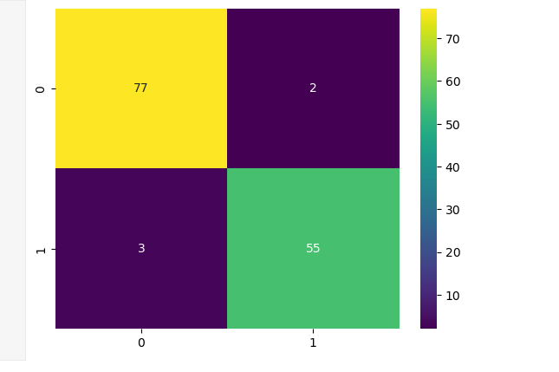

* True Negatives (77) – Correctly identified benign samples.
* True Positives (55) – Correctly identified malignant samples.
* False Positives (2) – Benign misclassified as malignant.
* False Negatives (3) – Malignant missed.

**Value Proposition**

**Operational Gains**

* Faster diagnostic turnaround times.
* Prioritization of high-risk cases.
* Reduced workload variability among staff.
* Enhanced diagnostic consistency and traceability.

**Patient Impact**

* Quicker preliminary results.
* Shorter wait times for review.
* More efficient and confident care pathways.

**Conclusion**

This **Breast Cancer SVM Classification Model** achieves 96.4% accuracy and 0.997 AUC, showing exceptional reliability in differentiating benign and malignant samples.

When integrated as a clinical decision support tool, it can significantly:

* Improve diagnostic efficiency
* Enhance workflow consistency
* Support faster, more confident patient management